- Basswood body
- Bolt-on hardrock Maple neck
- Burns original headstock
- Classic polyester finish
- Rosewood fingerboard
- Scale Length 25.5"
- Nut Width 49mm
- Truss rod Bi-flex two way type
- 21 frets
- Chrome hardware as standard
- Burns® de-luxe machine heads
- 3 x Burns® Tri-Sonic® pickups
- Five-way pickup switch
- Push/pull pickup selector
- One master volume
- Two-tone controls
- Rez-o-Tube® tremolo system
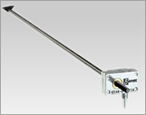
Burns® Gear-o-Matik™ Gearbox
This Burns gearbox was first designed by Jim Burns in 1960 to allow fine neck setting. Coupled to the steel truss rod tensioned through the neck to a gearbox with a hefty cog and worm which provides micro adjustment.

